
Symbiosis Institute of Technology, Pune
Faculty of Engineering
CSE- Academic Year 2026-27
Java Programming – Lab Batch 2025-29
Lab Assignment No:- 30
Name of Student | Aarushi Raizada
PRN No. | 25070122002
Batch | 2025-29
Class | A1
Academic Year & Semester | 2026 SEM III
Date of Submission | 17/10/26
Title of Assignment: | Write a JSP application to demonstrate CRUD operations.
Theory  Practice questions | CRUD stands for Create, Read, Update, and Delete, which represent the four basic database  operations performed in web applications. JSP works together with Servlets and JDBC to implement  these operations. Users interact with HTML forms created using JSP, while JDBC executes SQL  statements to manipulate database records. INSERT adds new records, SELECT retrieves  information, UPDATE modifies existing data, and DELETE removes unwanted records. Proper  validation, exception handling, and session management improve application reliability and security.  JSP CRUD applications are widely used in employee management systems, online shopping portals,  hospital management systems, banking applications, and other enterprise software.  - Create a JSP-based application to add, update, delete, and view employee details  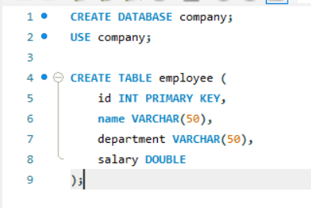  db.jsp  <%@ page import="java.sql.*" %>  <%  Class.forName("com.mysql.cj.jdbc.Driver");  Connection con = DriverManager.getConnection(  "jdbc:mysql://localhost:3306/company",  "root",  "your_password"  );  %>  employee.jsp  <%@ page import="java.sql.*" %>  <%  String url = "jdbc:mysql://localhost:3306/company";  String user = "root";  String pass = "your_password";  String action = request.getParameter("action");  String msg = "";  try {  Class.forName("com.mysql.cj.jdbc.Driver");  try (Connection con = DriverManager.getConnection(url, user, pass)) {  if ("add".equals(action)) {  try (PreparedStatement ps = con.prepareStatement(  "INSERT INTO employee VALUES (?, ?, ?, ?)")) {  ps.setInt(1, Integer.parseInt(request.getParameter("id")));  ps.setString(2, request.getParameter("name"));  ps.setString(3, request.getParameter("dept"));  ps.setDouble(4, Double.parseDouble(request.getParameter("salary")));  ps.executeUpdate();  msg = "Employee added successfully!";  }  }  if ("update".equals(action)) {  try (PreparedStatement ps = con.prepareStatement(  "UPDATE employee SET name=?, department=?, salary=? WHERE id=?")) {  ps.setString(1, request.getParameter("name"));  ps.setString(2, request.getParameter("dept"));  ps.setDouble(3, Double.parseDouble(request.getParameter("salary")));  ps.setInt(4, Integer.parseInt(request.getParameter("id")));  int n = ps.executeUpdate();  msg = n > 0 ? "Employee updated successfully!" : "Employee not found.";  }  }  if ("delete".equals(action)) {  try (PreparedStatement ps = con.prepareStatement(  "DELETE FROM employee WHERE id=?")) {  ps.setInt(1, Integer.parseInt(request.getParameter("id")));  int n = ps.executeUpdate();  msg = n > 0 ? "Employee deleted successfully!" : "Employee not found.";  }  }  }  } catch (Exception e) {  msg = "Error: " + e.getMessage();  }  %>  <!DOCTYPE html>  <html>  <head>  <title>Employee Management</title>  </head>  <body>  <h2>Employee Management System</h2>  <p><%= msg %></p>  <form method="post">  Employee ID: <input type="number" name="id" required><br><br>  Name: <input type="text" name="name" required><br><br>  Department: <input type="text" name="dept" required><br><br>  Salary: <input type="number" step="0.01" name="salary" required><br><br>  <button name="action" value="add">Add</button>  <button name="action" value="update">Update</button>  <button name="action" value="delete">Delete</button>  <button type="button" onclick="location.href='employee.jsp'">  View All  </button>  </form>  <h3>Employee Records</h3>  <table border="1" cellpadding="8">  <tr>  <th>ID</th><th>Name</th><th>Department</th><th>Salary</th>  </tr>  <%  try {  Class.forName("com.mysql.cj.jdbc.Driver");  try (Connection con = DriverManager.getConnection(url, user, pass);  Statement st = con.createStatement();  ResultSet rs = st.executeQuery("SELECT * FROM employee")) {  while (rs.next()) {  %>  <tr>  <td><%= rs.getInt("id") %></td>  <td><%= rs.getString("name") %></td>  <td><%= rs.getString("department") %></td>  <td><%= rs.getDouble("salary") %></td>  </tr>  <%  }  }  } catch (Exception e) {  out.println("<tr><td colspan='4'>Unable to display records.</td></tr>");  }  %>  </table>  </body>  </html>  2. Create a JSP-based application to manage patient records using CRUD operations. Include fields  such as patient ID, name, age, disease, and treatment status.  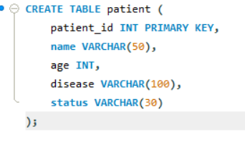  Patient.jsp  <%@ page import="java.sql.*" %>  <%  String url = "jdbc:mysql://localhost:3306/company";  String user = "root";  String pass = "your_password";  String action = request.getParameter("action");  String msg = "";  try {  Class.forName("com.mysql.cj.jdbc.Driver");  try (Connection con = DriverManager.getConnection(url, user, pass)) {  if ("add".equals(action) || "update".equals(action)) {  String sql = "add".equals(action)  ? "INSERT INTO patient VALUES (?, ?, ?, ?, ?)"  : "UPDATE patient SET name=?, age=?, disease=?, status=? WHERE patient_id=?";  try (PreparedStatement ps = con.prepareStatement(sql)) {  int id = Integer.parseInt(request.getParameter("id"));  String name = request.getParameter("name");  int age = Integer.parseInt(request.getParameter("age"));  String disease = request.getParameter("disease");  String status = request.getParameter("status");  if ("add".equals(action)) {  ps.setInt(1, id);  ps.setString(2, name);  ps.setInt(3, age);  ps.setString(4, disease);  ps.setString(5, status);  } else {  ps.setString(1, name);  ps.setInt(2, age);  ps.setString(3, disease);  ps.setString(4, status);  ps.setInt(5, id);  }  int n = ps.executeUpdate();  msg = n > 0 ? "Operation successful!" : "Patient not found.";  }  }  if ("delete".equals(action)) {  try (PreparedStatement ps = con.prepareStatement(  "DELETE FROM patient WHERE patient_id=?")) {  ps.setInt(1, Integer.parseInt(request.getParameter("id")));  int n = ps.executeUpdate();  msg = n > 0 ? "Patient deleted successfully!" : "Patient not found.";  }  }  }  } catch (Exception e) {  msg = "Error: " + e.getMessage();  }  %>  <!DOCTYPE html>  <html>  <head>  <title>Patient Management</title>  </head>  <body>  <h2>Patient Record Management</h2>  <p><%= msg %></p>  <form method="post">  Patient ID: <input type="number" name="id" required><br><br>  Name: <input type="text" name="name" required><br><br>  Age: <input type="number" name="age" required><br><br>  Disease: <input type="text" name="disease" required><br><br>  Treatment Status:  <select name="status">  <option>Admitted</option>  <option>Under Treatment</option>  <option>Recovered</option>  <option>Discharged</option>  </select><br><br>  <button name="action" value="add">Add</button>  <button name="action" value="update">Update</button>  <button name="action" value="delete">Delete</button>  <button type="button" onclick="location.href='patient.jsp'">  View All  </button>  </form>  <h3>Patient Records</h3>  <table border="1" cellpadding="8">  <tr>  <th>ID</th><th>Name</th><th>Age</th>  <th>Disease</th><th>Treatment Status</th>  </tr>  <%  try {  Class.forName("com.mysql.cj.jdbc.Driver");  try (Connection con = DriverManager.getConnection(url, user, pass);  Statement st = con.createStatement();  ResultSet rs = st.executeQuery("SELECT * FROM patient")) {  while (rs.next()) {  %>  <tr>  <td><%= rs.getInt("patient_id") %></td>  <td><%= rs.getString("name") %></td>  <td><%= rs.getInt("age") %></td>  <td><%= rs.getString("disease") %></td>  <td><%= rs.getString("status") %></td>  </tr>  <%  }  }  } catch (Exception e) {  out.println("<tr><td colspan='5'>Unable to display records.</td></tr>");  }  %>  </table>  </body>  </html>
Output Screenshots (if applicable) | Ans 1    Ans 2  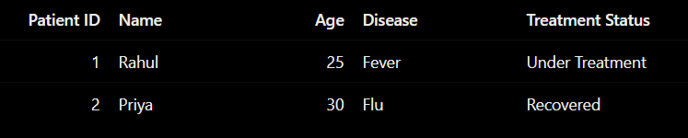
Conclusion | Successfully developed JSP applications using JDBC and MySQL to perform Create, Read, Update, and Delete operations on employee and patient records.

